World Premiere of ‘The Colony’ Weaves Together Animation, Theater, Music, and Science
Anna Lindemann’s New Cross-Disciplinary Performance Delves Into the Social Lives of Ants and Humans (September 6 - 8)
CONTACT
Michael Hofmann
201-936-5379
thecolonyshow@gmail.com
08-09-2019
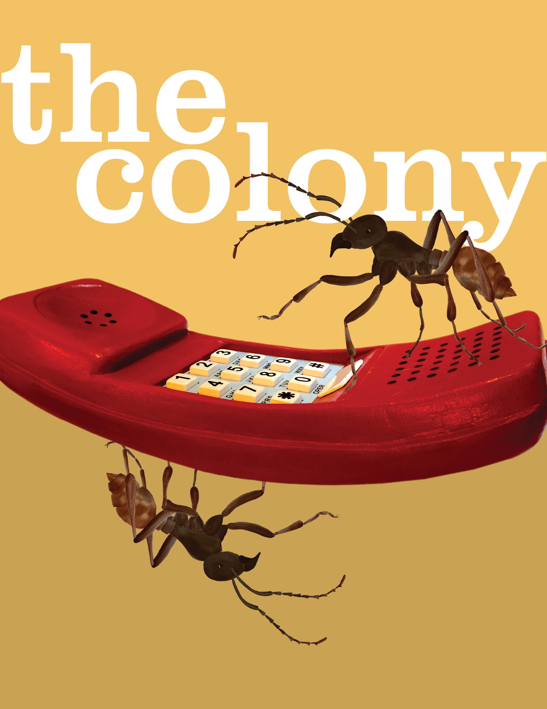
Image design by Michael Hofmann. Download here

“A unique tour-de-force of science-inspired art. Anna Lindemann is a brilliant animator, composer, and performer… [her] work marks the birth of a whole new genre.”
— David Rothenberg (author, philosopher, musician)

STORRS, CT: Animator, composer, and performer Anna Lindemann premieres her newest work, The Colony, an art-science performance about sisterhood and the evolution of communication in two of the most social creatures on earth: humans and ants. Three performances on September 6 - 8 take place at the Studio Theatre, located on the University of Connecticut Storrs campus. Tickets are free, with reservations highly recommended by visiting www.thecolony.show.

In this performance, Lindemann herself portrays the loving, bookish, and stubborn Mona as she struggles to reconnect with her estranged relatives, performed by soprano Lucy Fitz Gibbon and pianist Ryan MacEvoy McCullough. Mona turns to the ant colony for inspiration and direction. With more than 500,000 ant sisters migrating, raiding, and even reproducing as one superorganism, an army ant colony appears to Mona as the paragon of successful social existence. Co-written by Lindemann and Emma Komlos-Hrobsky and directed by Michael Hofmann, The Colony ventures into speculative fiction and includes projected animations and imagery alongside live spoken and musical performance, all informed by scientific research on ant colonies.

Funny, poignant, enlightening, and just the right amount of strange, The Colony aims to kindle a sense of awe and understanding of our diverse biological world, while using the ant colony as a lens for understanding the ever-present challenge of human connection. As part of a new genre called Evo Devo Art, The Colony weaves together evolutionary and developmental biology (Evo Devo) with multidisciplinary art. Audiences can expect to be entranced by visualizations of ant pheromone trails, a musical aria from the perspective of an ant queen, and a dance sequence set in a grocery store inspired by army ant swarm raids. In all, The Colony juxtaposes forms of biological communication – which have developed over millions of years – with modern technological media as a means of grappling with the paradox of acute loneliness in a world more connected than ever.

The Colony’s script is co-written by Lindemann and Emma-Komlos Hrobsky; Lindemann also composed the music and directed animations by Sarah Shattuck, Jasmine Rajavadee, Allie Marsh, and herself. Michael Hofmann directs, with costumes by Brittny Mahan, lights by Sam Biondolillo, sound by Katie Salerno, and additional film direction by Ryan Glista.

The Colony draws visual materials and research in part from the world-class Carl W. and Marian E. Rettenmeyer Army Ant Guest Collection housed at the University of Connecticut and is one of a number of “AntU” initiatives inspired by the collection.

The Colony is made possible through the generous support of the Department of Economic and Community Development, Connecticut Office of the Arts; the University of Connecticut School of Fine Arts Dean’s Grant and the Office of the Vice President for Research; the University of Connecticut School of Fine Arts Project Completion Grant; the University of Connecticut Department of Digital Media & Design; and a grant from the University of Connecticut Provost’s Academic Plan competition for the AntU project.

www.thecolony.show
www.instagram.com/thecolonyshow

Who’s Who of The Colony

Anna Lindemann (writer, composer, animator, role of Mona) calls herself an Evo Devo artist. Her work combines animation, music, video, and performance to explore the emerging field of Evolutionary Developmental Biology (Evo Devo). Her work seeks to uncover narratives within rigorous scientific research, to visualize biological processes in novel ways, to define new artistic creative processes modeled on biological processes, and to examine the human emotion and subjectivity behind scientific research. Her Evo Devo Art, including the animated short Beetle Bluffs and the art-science performance Theory of Flight, has been featured nationally and internationally at black box theaters, planetariums, galleries, concert halls, biology conferences, film festivals, digital art conferences, natural history museums and in the book Survival of the Beautiful: Art, Science, and Evolution.

Anna graduated magna cum laude with honors from Yale with a BS in Biology before receiving an MFA in Integrated Electronic Arts from Rensselaer Polytechnic Institute. She is an Assistant Professor in the Digital Media & Design Department at the University of Connecticut where she has pioneered courses integrating art and science. She is currently co-director of the AntU Academic Plan at UConn, which involves 16 innovative interdisciplinary activities inspired by a world-class collection of army ants and their guests. Anna first conceived of The Colony three years ago and she has been delighted to work with a wonderful and diverse team of collaborators in bringing the project to life.

For more about her work, visit: www.annalindemann.com

Emma Komlos-Hrobsky (writer) is a writer, illustrator, and editor who tells stories at the intersection of the human, and the fantastic. A creative polymath, Emma’s work often combines word and image to create narrative through maps, mail art, comics, and forms beyond category. She has a particular interest in the ways the ideas of science can provide new means of relating human experience and emotion. For nine years, as an editor at Tin House magazine and Tin House Books, she collaborated with such luminaries as Sy Montgomery, Louise Erdrich, Kelly Link, Rebecca Makkai, Alexandra Kleeman and Steve Almond. Her editorial work has been honored by Best American Essays, The Pushcart Prize, and The O. Henry Prize, and has been anthologized in a collection that was a finalist for the Pulitzer Prize. She also founded and directed the Tin House Craft Intensives, a pioneering brand of writing workshop held in the magazine's Brooklyn offices.
Emma received her BA from Wesleyan and her MFA in fiction writing from The New School, where she later taught as an associate professor. She has mentored writers as a guest teacher at Columbia, NYU, Colgate, Fairleigh-Dickinson, and the University of Connecticut, as well as for the Masters Review and Writers @ Work. Her writing has appeared in Guernica, Hunger Mountain, Conjunctions, Bookforum, Tin House, Hobart, and The Story Collider. She currently serves as associate editor at Poets & Writers. With the support of a fellowship from the Elizabeth George Foundation, she is at work on a novel about particle physics, family, and the Alps.

For more about her work, visit: www.emmakomloshrobsky.com

Noted for her “dazzling, virtuoso singing” (Boston Globe), Lucy Fitz Gibbon (soprano, role of Hennie) is a dynamic musician whose repertoire spans the Renaissance to the present. She believes that creating new works and recreating those lost in centuries past makes room for the multiplicity and diversity of voices integral to classical music’s future. As such, she has worked closely with eminent composers including Pauline Oliveros, John Harbison, Kate Soper, and Reena Esmail, among many others; The Colony marks her fourth collaboration with Anna Lindemann.

Lucy’s 2019-2020 season highlights include two different tours with Musicians from Marlboro (venues including Carnegie Hall, Philadelphia’s Kimmel Center, and the Isabella Stewart Gardner Museum), Bach’s St. Matthew Passion with the Kalamazoo Symphony, Canteloube’s Chants d’Auvergne with the Eureka Symphony, Vaughan Williams’ Sea Symphony at Cornell University, and the premieres of a work by Shirish Korde with Boston Musica Viva and a new arrangement of Foss’ Time Cycle by Barbara Kolb. As a recitalist Lucy has appeared with her husband and collaborative partner, pianist Ryan McCullough, in such venues as London’s Wigmore Hall; New York’s Metropolitan Museum of Art, Park Avenue Armory, and Merkin Hall; and Toronto’s Koerner Hall. In 2020, they will give recitals at NYC’s DiMenna Center, SongFest, and the Fall Island Vocal Arts Seminar, premiering a work written for them by Alan Louis Smith. Three forthcoming CDs feature works by Harbison and James Primosch (Albany Records), Sheila Silver (alongside Dawn Upshaw and Stephanie Blythe), and mid-20th century Polish composers (Acte Préalable).

For more about her work, visit: www.lucyfitzgibbon.com

American pianist Ryan MacEvoy McCullough (piano, role of Ian) has worked to stretch his musicianship in every way possible, working with music old and new as soloist, collaborator, recording artist, and pedagogue, and at times as programmer, sound diffusionist, and engineer. His multi-faceted interests have developed a repertoire that balances not only the canonical with the unknown, but also aesthetics from the classical sublime to the noise of electronic experimentalism. His work as a performer includes not only careful attention to written text, but also the instruments of performance, from historical keyboards to recreations of instruments from canonical electroacoustic works. Despite this diversity of musical activity, his aim is to find “the sound” that best clarifies the music at hand, whatever the circumstances. Ryan has worked closely with some of today's foremost composers, and has had many works written for him, including by John Harbison, James Primosch, Carter Pann, John Liberatore, Christopher Stark, and Dante De Silva. Ryan's growing discography of new works includes Andrew McPherson's Secrets of Antikythera for magnetic resonator piano on Innova, solo piano music of John Liberatore on Albany Records, and the complete piano works of Australian composer Nicholas Vines on Navona. A forthcoming album of vocal and piano works by Harbison and Primosch will appear on Albany Records with soprano (and wife) Lucy Fitz Gibbon. Mr. McCullough studied primarily with Deborah Clasquin, David Louie, and John Perry, in addition to influential work with Stephen Drury, Leon Fleisher, and Xak Bjerken. Ryan holds degrees from Humboldt State University, Colburn Conservatory, University of Southern California, Glenn Gould School, and Cornell University.

For more about his work, visit: www.RyanMMcCullough.com

Michael Hofmann (consulting director) is a performer, arts administrator, artist, and opera stage director based in the Hudson Valley and New York City. Hofmann's directorial debut, a semi-staged production of Bernstein's Candide with The Orchestra Now in February 2017, was noted as "stunning in its brilliance, humor, and overall gestalt... an astonishing accomplishment" (Millbrook Independent). Other operatic production credits include stage director for Bard College’s 2018-19 Opera Workshop scenes program, stage director for the June 2018 east coast premiere of Constantin Basica’s Knot an Opera with Fresh Squeezed Opera, and assistant stage director for R. B. Schlather’s November 2017 production of The Mother of Us All in Hudson, New York.

Hofmann enjoys a diverse schedule of small ensemble singing, freelance graphic design, and administrative work as the Executive Assistant of the Fisher Center at Bard. He sings regularly with the Church of St. Luke in the Fields and appears on the ensemble’s critically acclaimed November 2018 recording of Palestrina’s Missa Tu Es Petrus. Memorable performances include the sold-out July 2017 New York City premiere of Griffin Candey's Sweets By Kate as Joe Brigmann at Stonewall Inn, and his three seasons as a core ensemble member of the medieval music drama, The Play of Daniel at Trinity Wall Street, produced by Gotham Early Music Scene and directed by Drew Minter. A New Jersey native, Hofmann trained as a multi-instrumentalist through high school; he later earned a B.A. in music from Vassar College and an M.M. in voice from the Bard College Conservatory of Music’s Graduate Vocal Arts Program.

For more about his work, visit: www.mkhofmann.com

AntU is an endeavor designed to involve a variety of academic disciplines to engage a broad audience in the wonders of the complex biological systems of army ants and their hundreds of associated species (“guests"). It is an idea borne out of an award from the National Science Foundation (NSF) Collections in Support of Biological Research program to the Department of Ecology & Evolutionary Biology (EEB), in partnership with the Connecticut State Museum of Natural History (CSMNH), to preserve and curate the Carl W. and Marian E. Rettenmeyer Army Ant Guest Collection. This world-class collection of over 2 million army ants and their guests is the result of 50 years of careful, detailed fieldwork in Central and South America by the Rettenmeyers.

Over the last three years, with additional support from a UConn Provost's competition award, this multi-faceted, highly interdisciplinary endeavor has expanded to include partners from Digital Media & Design (DMD), Poetry, Puppetry, Art and Art History, Mechanical Engineering, Management and Engineering for Manufacturing (MEM), the Humanities Institute, Cooperative Extension in the College of Agriculture, Health and Natural Resources, The Neag School of Education, the Office of the Registrar, Facilities Operations and Building Services (FOBS), and the list continues to grow! AntU activities have included interactive exhibits, poems, robots, and puppetry pageants. Upcoming AntU activities, in addition to the premiere of The Colony, include an exhibit of specially-commissioned puppets at the Ballard Institute and Museum of Puppetry and an installation of Colombian Artist Rafael Gomezbarros’ “Casa Tomada” (“House Taken”) on buildings across campus.

For more about AntU, visit: www.antu.uconn.edu

View additional biographies of the creative team for The Colony by visiting https://www.thecolony.show/#creative-team-section.

World Premiere
The Colony
An art-science performance on social life by Anna Lindemann

Script by Anna Lindemann and Emma Komlos-Hrobsky

Mona - Anna Lindemann
Hennie / Soprano / Ant Queen - Lucy Fitz Gibbon
Ian / Keyboard - Ryan MacEvoy McCullough

Composer - Anna Lindemann
Animation Art Director - Anna Lindemann
Animators - Sarah Shattuck, Jasmine Rajavadee, Allie Marsh, Anna Lindemann
Film Direction - Ryan Glista and Anna Lindemann

Consulting Director - Michael Hofmann
Costume Designer - Brittny Mahan
Lighting Designer - Sam Biondolillo
Sound Engineer and Sound Designer - Katie Salerno

(Full performance credits can be found at https://www.thecolony.show/#credits-section)

The Studio Theatre
802 Bolton Rd, Storrs, CT 06269
University of Connecticut

Friday, September 6 at 8:00 pm
Saturday, September 7 at 8:00 pm
Sunday, September 8 at 2:00 pm

Tickets: Free, reservations encouraged
Reserve by visiting www.thecolony.show or Eventbrite: https://www.eventbrite.com/e/the-colony-tickets-66080310989

# # #

